Section 2.6 Statistics (reference 2.6)
Definitions:
Population: The set of all possible observations
Sample: Any subset of a population
Homogeneous Sample: The sample comes from 1 population only
Random Sample: Equal probability of selecting any member of the population Independence (of events A and B): P(A and B) = P(A)*P(B)

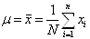
Sample and Population Mean (Average value):

Mode (Most commonly occurring value in a sample)
Median (middle value, 50th percentile. Half of the sample values are greater and half are smaller)
Deviation (from the mean value):

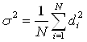
Population Variance (from the mean value):

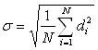
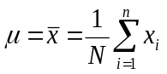
Population Standard Deviation (from the mean value):

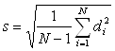
Sample Standard Deviation (from the mean value):

Discrete Probability Distributions:
Binomial: N independent events, each having probability p of success, and1-p of failure. For example, tossing a fair coin N times where p = the probability of getting a head on any toss. If the random variable x indicates the number of heads in N=2 tosses, then P(x=0) = 1/4, P(x=1) = 1/2, P(x=2) = 1/4. If N=4, then the probabilities are illus trated in the following graph:
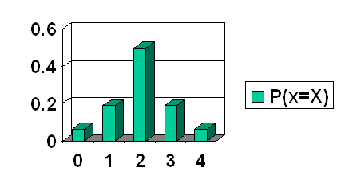
As N approaches infinity ...

